Chapter 9: Testing a Claim

Key Vocabulary: | power
Null Hypothesis | standard error
Alternative Hypotheses | t distribution
Inference Toolbox | degrees of freedom
test statistic | paired t-test
p-value | one-sample z statistic
level | one-sample t statistic
one-sample z statistic | two-sample t statistic
statistically significant | robust
Type I Error | power
Type II Error

9.1 Significance Tests: The Basics (pp.528-546)
- What is a significance test?

- What is a null hypothesis?

- What is an alternative hypothesis?

- Explain the difference between a one-sided alternative hypothesis and a two-sided alternative hypothesis.

CYU pg 532
1a) parameter of interest =
b) Ho =
Ha =
2a) parameter of interest =
b) Ho =
Ha =

- In statistics, what is meant by the P-value?

- If a P-value is small, what do we conclude about the null hypothesis?

- If a P-value is large, what do we conclude about the null hypothesis?

- If you fail to reject H_{o}, can you accept it?

- What is meant by a significance level?

- What does it mean if we say this is statistically significant?

- On what evidence would we reject the null hypothesis?

- On what evidence would we fail to reject the null hypothesis?

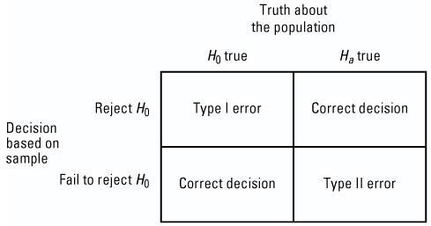
- What is a Type I Error?

- What is a Type II Error ?

CYU Page 539
1.

2.

3.

- What is the relationship between the significance level and the probability of Type I Error?

- What is meant by the power of a significance test?

- State two ways to increase the power of a significance test:

9.2 Tests about a Population Proportion (pp.549-562)
- What conditions must be verified before carrying out a significance test for a population proportion?

- State the general form of the “test statistic”.

- What does the test statistic measure?

- What 4 steps should you follow when you are performing a significance test?

- State the null hypothesis for a one-sample z test for a proportion.

- Give the formula for the one-sample z test for a proportion, and define each variable in the equation.

- State and use diagrams to illustrate the three possible alternative hypotheses for a one proportion z-test.

CYU Page 555
State:
Plan:

Do:

Conclude:
- If no α level is given what should you use?

- What additional information does a confidence interval provide that a significance test does not?

CYU Page 561

9.3 Tests about a Population Mean (pp.565-587)
- State the null hypothesis for a one sample t-test.

CYU Page 570
1.
2.

3.

- Give the formula for the one-sample t-statistic, and define each variable in the equation.

- When can we use one-sample t-test?

CYU Page 574
State:

Plan:

Do:

Conclude:

CYU Page 577
1.

2.

- When should a paired t- test be used, and what would be the statistic of interest?

